**Program 5:**

Design and implement C/C++ program to obtain the Topological ordering of vertices in a given digraph.

**Algorithm:**

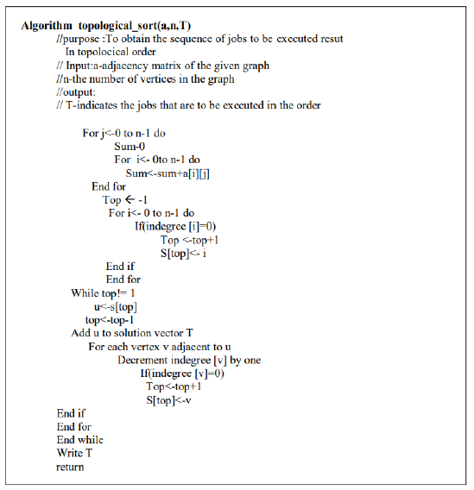

**Code:**

#include<stdio.h>

int cost[10][10],n,colsum[10];

void cal_colsum()

{

for(int j=0;j<n;j++)

{

colsum[j]=0;

for(int i=0;i<n;i++)

colsum[j]+=cost[i][j];

}

}

void source_removal()

{

int i,j,k,select[10]={0};

printf("Topological ordering is: ");

for(i=0;i<n;i++)

{

cal_colsum();

for(j=0;j<n;j++)

{

if(select[j]==0&&colsum[j]==0)

break;

}

printf("%d",j);

select[j]=1;

for(k=0;k<n;k++)

cost[j][k]=0;

}

}

void main()

{

printf("Enter the number of vertices: ");

scanf("%d",&n);

printf("Enter the cost matrix \n");

for(int i=0;i<n;i++)

for(int j=0;j<n;j++)

scanf("%d",&cost[i][j]);

source_removal();

}

**Output:**

